**Environmental Setup**

|  |  |
| --- | --- |
| Date | 16 October 2022 |
| Team ID | PNT2022TMID14584 |
| Project Name | Customer Care Registry |

**Flask Setup:**

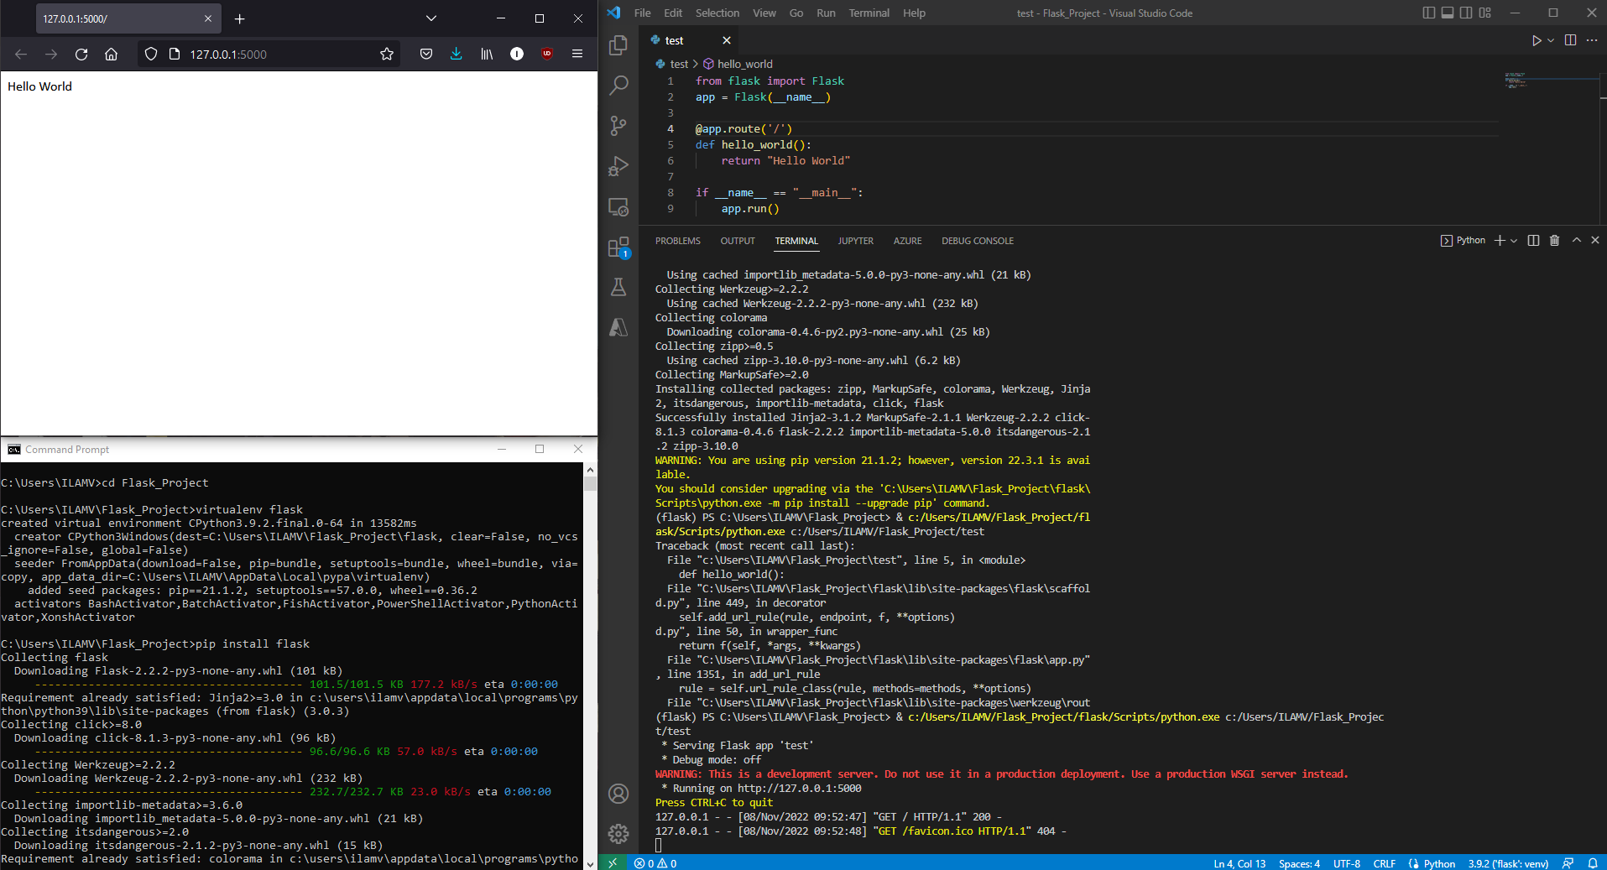

**Docker Setup:**

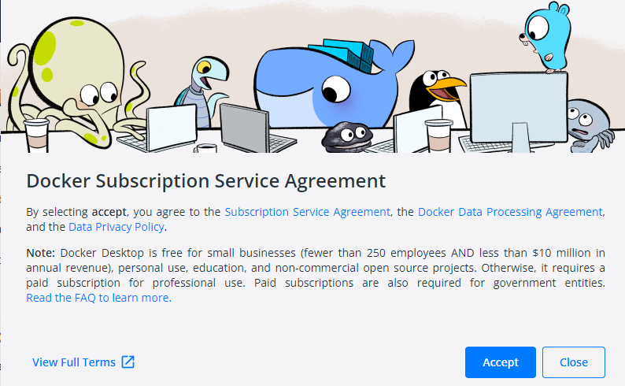

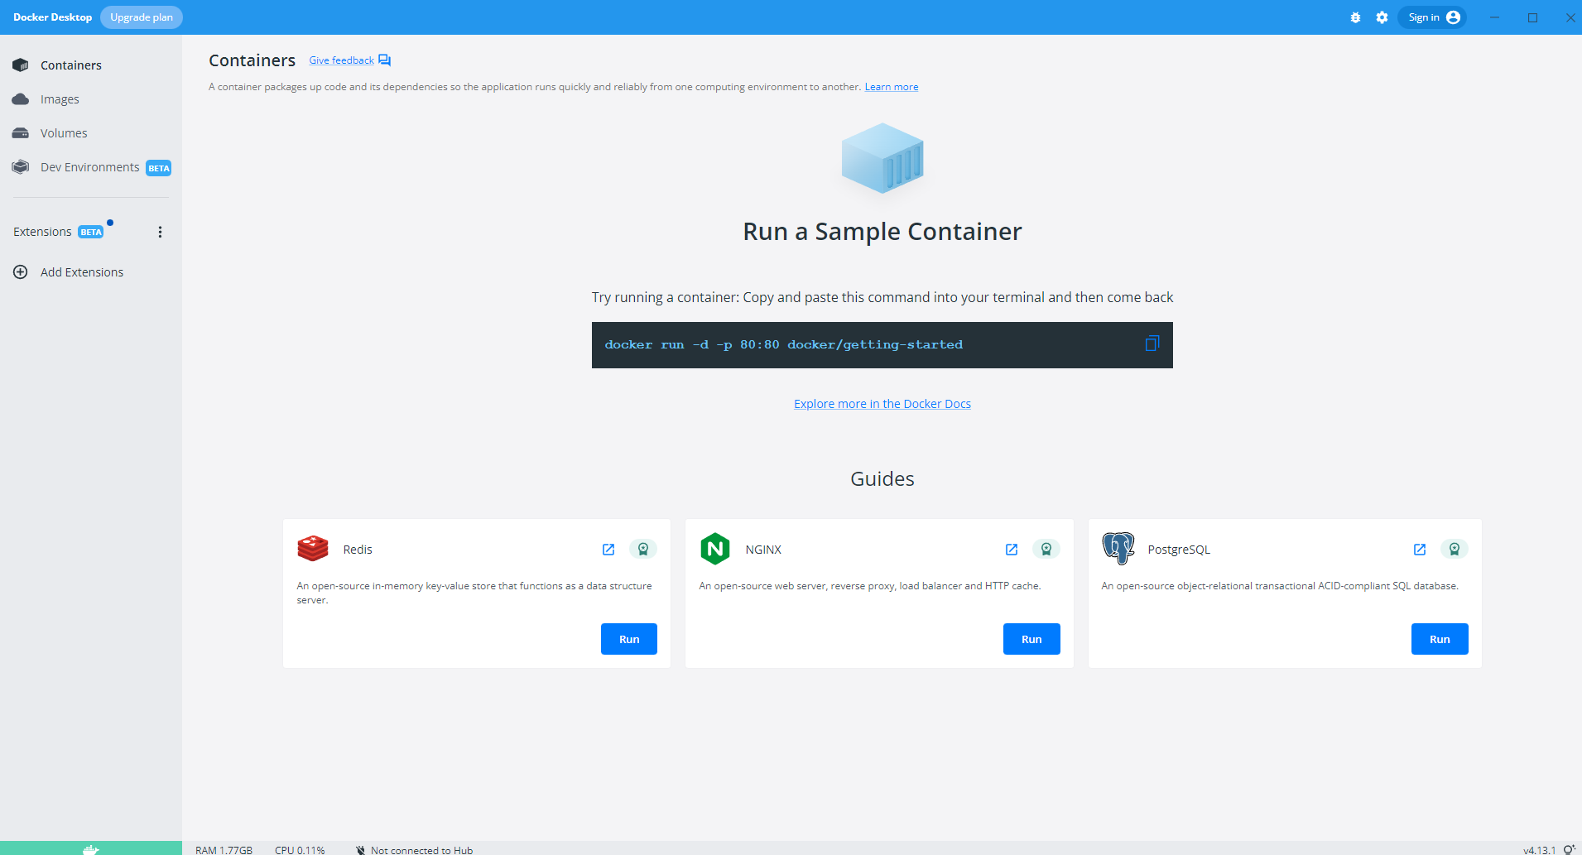

**Cloud Account Creation:**

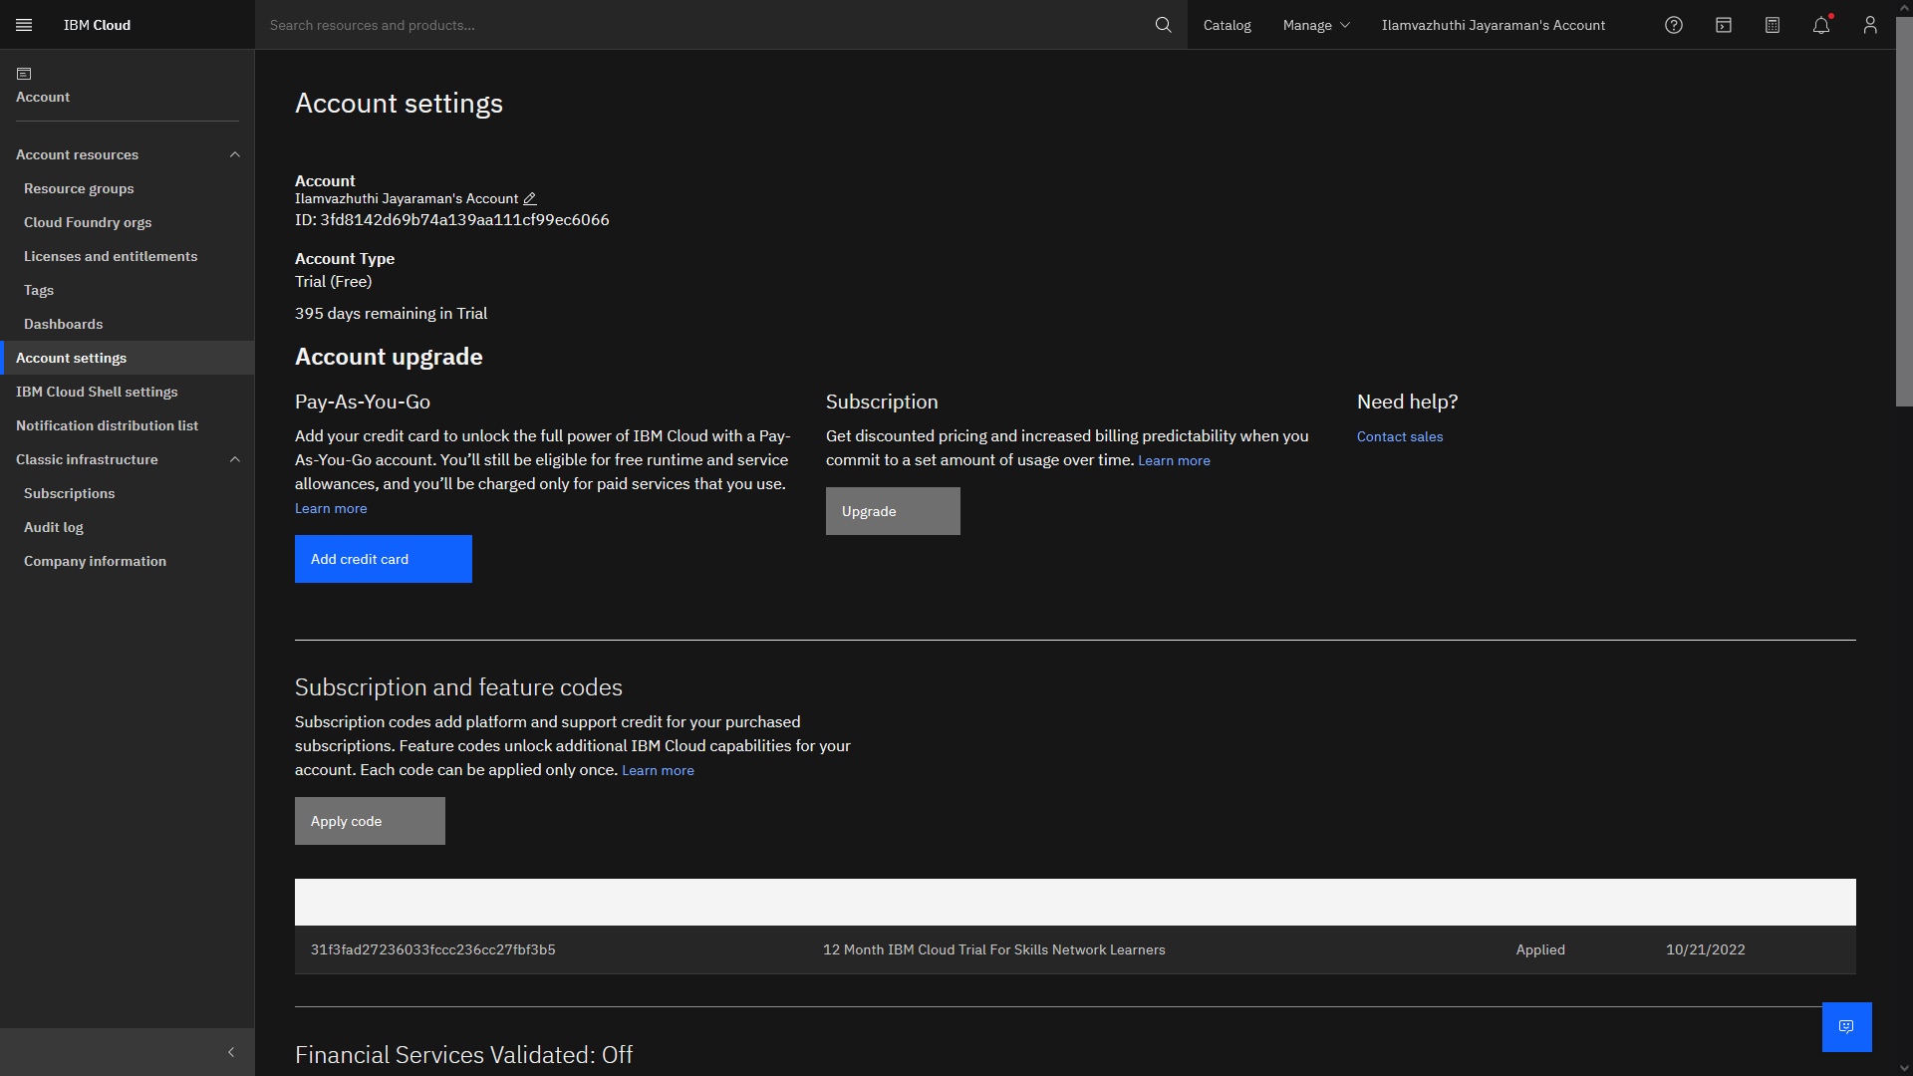

**Sendgrid Account Creation:**

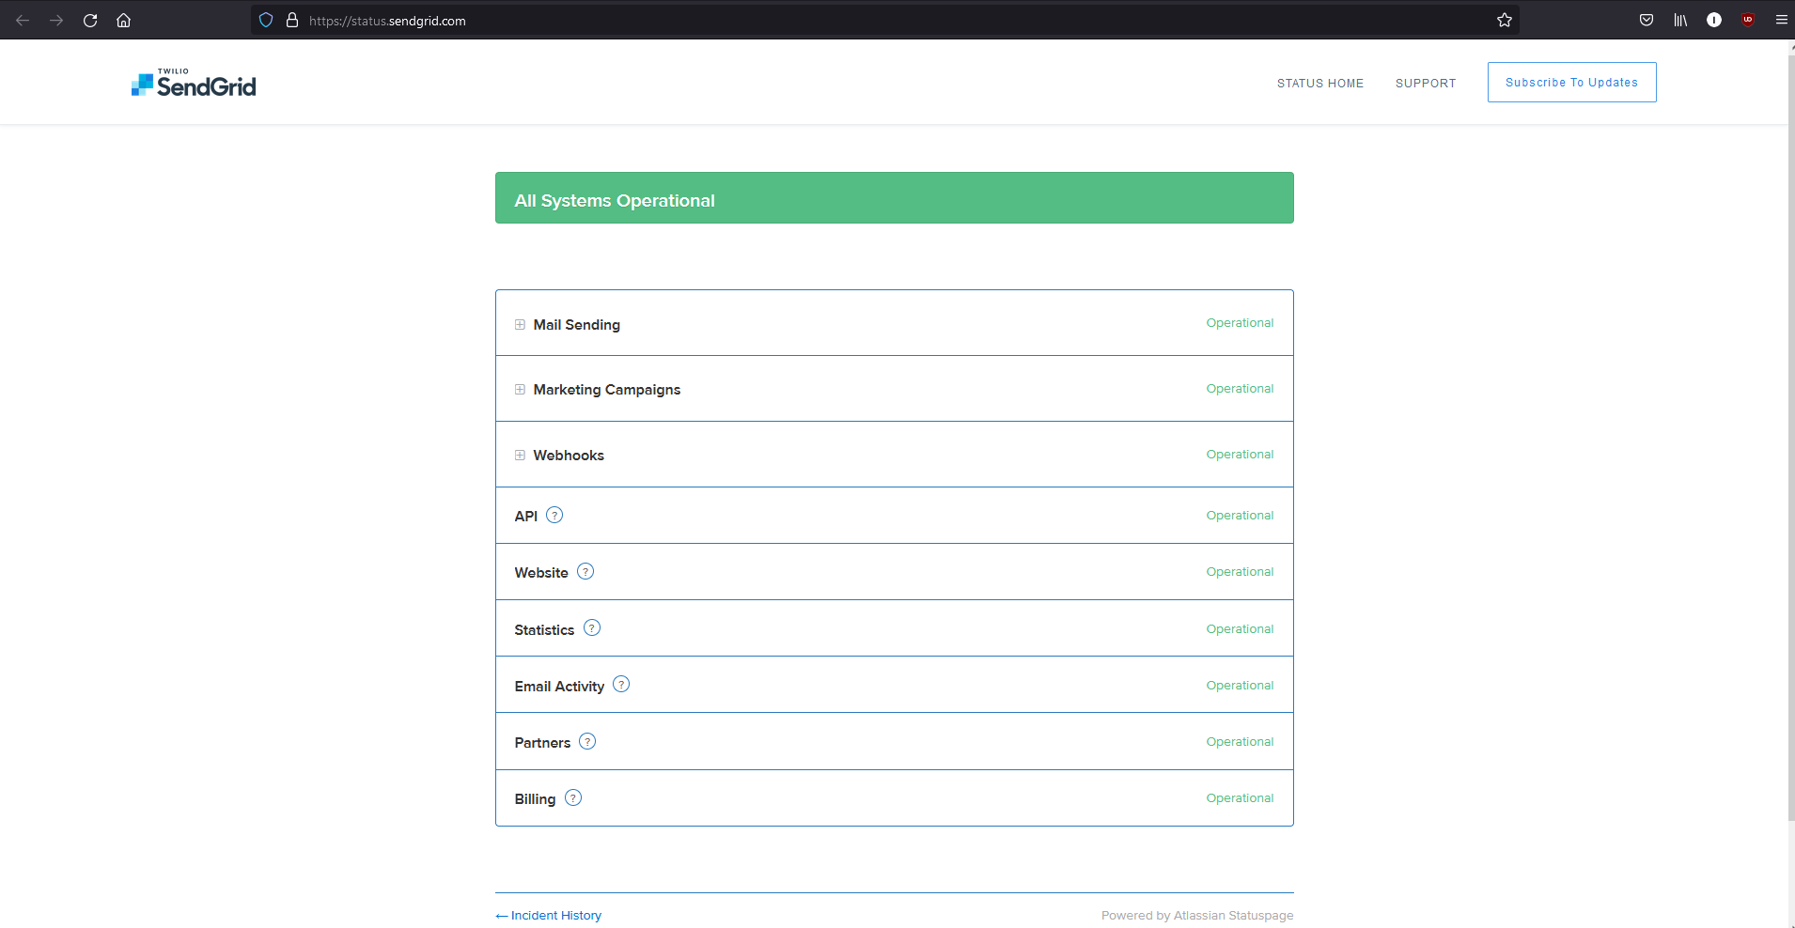

**IBM Cloud CLI Installation:**

